Cross-cutting Management Regime (NWFPs)
for
Dali Shingmen Tshogpa (1st Revision)
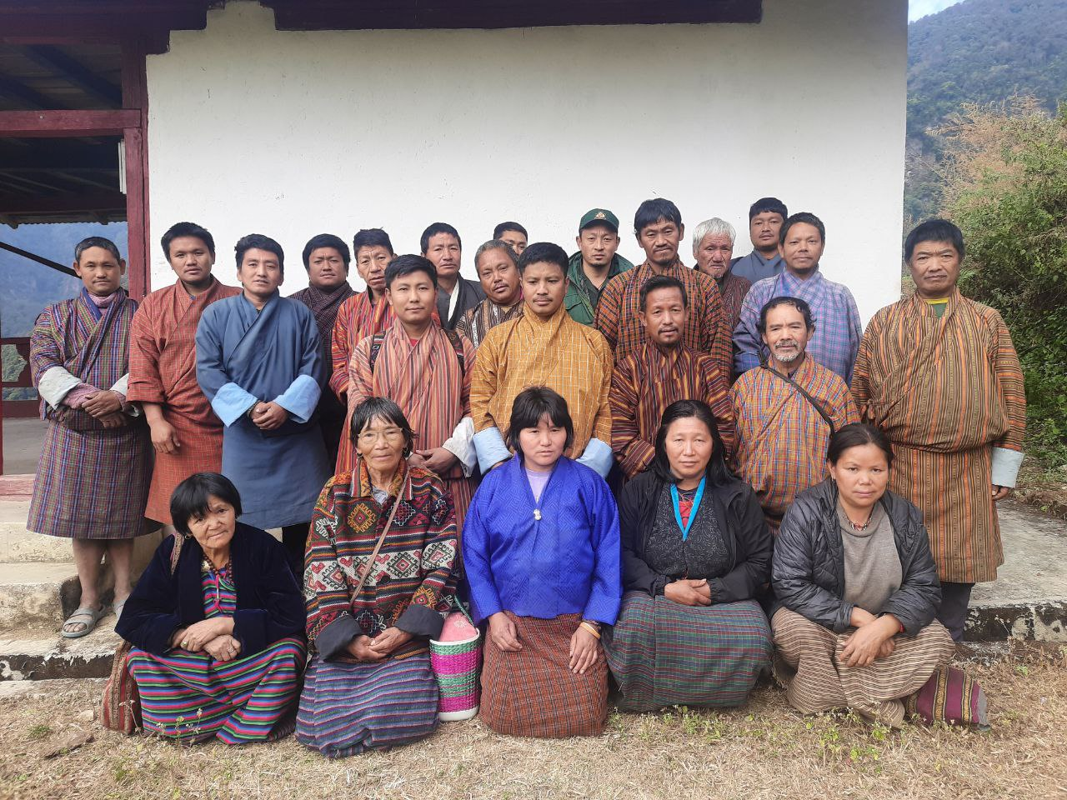

Name of NWFP Group: Dali Shingmen Tshogpa
Village: Dali
Gewog: Bjoka
Dzongkhag: Zhemgang
Plan Period: July 2025- June 2035

Approval Sheet
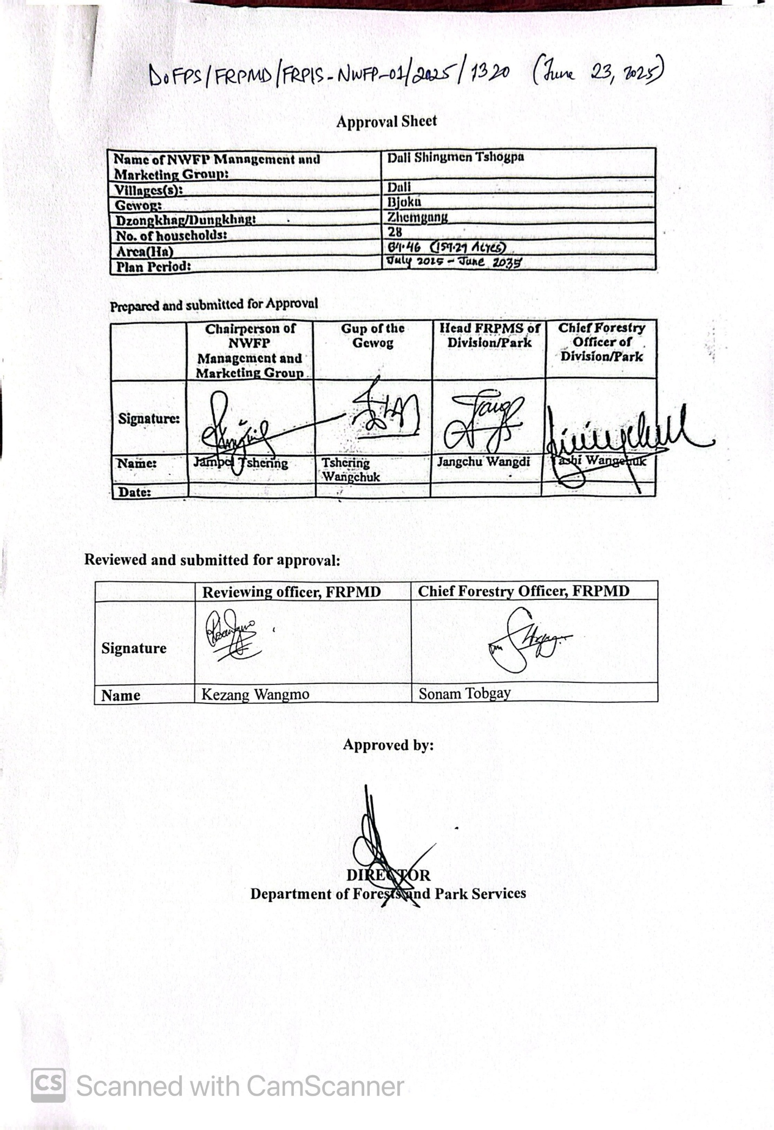

Table of Contents
Approval Sheet i
List of Figures ii
Acronyms iii
PART A: NWFP Management and Marketing Plan 1
1. Background 1
2. Goals and Objectives 1
3. Description of NWFPs 2
4. Harvesting prescriptions for sustainable NWFP collection 3
6. Marketing and sales plan 4
7. Marketing arrangements 4
8. Benefit to Members 5
8. Monitoring and Evaluation 5
Part B: Group Regulation and Norms (By-Law) 6
Powers of the Department 8
Annexure I: Membership list 9
Annexure II: Resource Assessment of Pipla 11
Annexure III: Resource Assessment of Rubia cordifolia 12

List of Figures
Figure 1. Pipla collection area map 3
Figure 2. Rubia collection area map 4
List of Tables
Table 1. Brief description of NWFPs for harvesting 2
Table 2. Sustainable harvesting prescriptions for NWFPs 3
Table 3. Marketing and sales plan 4

Acronyms

BDBL | Bhutan Development Bank Limited
DFO | Divisional Forest Office
FMEF | Forest Monitoring and Evaluation Framework
FRPMD | Forest Resources Planning and Management Division
FRPMS | Forest Resources Planning and Management Section
HH | Household
ITMS | Institute of Traditional Medicine Services
Kg | Kilogram
Km | Kilometer
KNC | Khenrig Namsum Cooperatives
NWFP | Non-wood Forest Produce

PART A: NWFP Management and Marketing Plan

1. Background
The cross-cutting management regime for sustainable management of non-wood forest products for Dali Shingmen Tshogpa falls with the Bjoka Local Forest Management Plan. The Dali Shingmen Tshogpa was formed in July 2020, and it is managed by 28 households from Dali village under Bjoka Gewog, Zhemgang Dzongkhag covering an area of 159.29 acres, encompassing the resource available areas within the chiwog. Previously, Dali village was accessible only by a three-hour walk from the Bjoka Gewog Administration, but it is now connected by a farm road, reducing the travel time to one hour by vehicle. The community primarily practices subsistence agriculture, with labor wages serving as a major source of income. Situated at an altitude of 1,396 meters above sea level, the warm broadleaf forests support a rich variety of Non-Wood Forest Products (NWFPs) that benefit local communities.
Currently, the community aims to manage and trade two key forest products: Pipla (Piper pedicellatum) and Rubia (Rubia cordifolia). However, given the diverse range of NWFPs found in the area, the group also plans to expand its operations to include other forest resources such as cane, bamboo, and low-altitude medicinal plants.
The Dali Shingmen Tshogpa’s first management plan was developed in close collaboration with the Divisional Forest Office, Zhemgang, and financially supported by the erstwhile Social Forestry and Extension Division under Department of Forests and Park Services (DoFPS). The current management plan revision is being carried out with co-financial assistance from Bjoka Gewog Administration and IKI Living Landscapes Project, WWF Bhutan.
To ensure sustainable management, the group has designated 67.5 acres of State Reserve Forest (SRF), which has been further divided into four blocks for the collection and management of Rubia cordifolia. Additionally, a separate area comprising 91.79 acres has been identified for Piper pedicellatum collection, divided into three blocks, namely Dembakhar, Yungsharbi and Poidhor.
This management plan spans ten years, during which the Divisional Forest Office, Zhemgang (DFO) and the Forest Resources Planning and Management Division will provide technical support, including training on harvesting techniques and monitoring activities in alignment with the plan’s objectives.

2. Goals and Objectives

- To empower community institutions for effective management of non-wood forest products (NWFP).
- To ensure sustainable harvesting of NWFP based on proper management guidelines.
- To improve livelihood earnings through the market-oriented sale of NWFP.

3. Description of NWFPs

3.1 Pipla (Piper pedicellatum)
It is a perennial plant growing up to 1-2meters in height and has dark-greenish leaves. The plant has unisexual reproductive units with male and female plants and only female bear the fruits. Pipla grows widely under the canopy of broadleaf forest or open areas at an altitude of 200-2200m. The plant thrives best in damp and moist soils with good shade. Fruit start ripening in August-September.
The management group will be collecting Pipla from three blocks namely, Dembakhar block (39.28 acres), Yungsharbi block (21.12 acres) and Poidhor block (31.38 acres) which are located at a distance of two to three hours walk and 30 minutes drive respectively from the village.

3.2 Tsuth (Rubia cordifolia)
Rubia cordifolia is a perennial climbing herb or straggling shrub belonging to the Rubiaceae family. It has slender, rough stems that climb with the help of tiny hooked prickles. The leaves are simple, rough, and arranged in whorls of 4 to 6 at each node, with a heart-shaped base and pointed tip. Its small greenish-yellow flowers are borne in terminal or axillary cymes and are bisexual and actinomorphic in structure. The fruit is a small, globose berry that turns from red to blackish-purple when ripe. The plant has long, thick red roots, which have historically been used as a natural dye and hold significant value in traditional medicine systems like Ayurveda.
Rubia cordifolia is locally known as La-nyi-roo, while in Dzongkha, it is known as Tsoy, and in Lhotshamkha, it is called Majito. Traditionally, the plant played a significant role in textile dyeing, particularly in handwoven garments, where its roots were used to extract a natural red dye. Additionally, it was believed to have protective properties, often applied to scratches caused by spiritual or supernatural influences (Sondrey), where the plant extract was rubbed onto affected areas.
The entire plant has multiple uses, with its roots being particularly valuable. They contain an anthraquinone compound known as purpurin, which produces a red pigment used in textile dyeing. Beyond its role in dyeing, Rubia cordifolia has various medicinal applications, including treating dry skin, reducing cholesterol levels, purifying blood, and aiding in blood clotting. Its diverse uses make it an important plant in both traditional medicine and textile industries.
Table 1. Brief description of NWFPs for harvesting
NWFP Name | Harvesting area | Parts harvested | Use/purpose (Traditional & others) | Harvesting season (months) | Estimated quantity for harvest in a season/year
Piper pedicellatum (Raktang) | Dembakhar, Yungsharbi, & Poidhor | Fruits | Spice/medicine | September to November | 83.4 kgs
Rubia cordifolia (Tsuth) | Yaliwa, Pongseng, Pong Nadhang & Bamdarlung | Entire plant | Dye, medicine | November to February | 702.96 kgs.

4. Harvesting prescriptions for sustainable NWFP collection

The chairperson will collect permit from Forest Office in the name of the group and inform the members to proceeds for harvesting. Only one member from each household will be allowed for collection of NWFP products during the season for a period of one week and after that, number of collectors will not be restricted.

Collection will be carried out strictly within the designated areas as per the management plan and harvesting prescription stated in Table 2.
Table 2. Sustainable harvesting prescriptions for NWFPs
NWFP Species | Harvesting prescription
Pipla (Piper pedicellatum) | - Collect fruits only when fully mature.  - Harvest fruits only after the announced starting date for harvesting that is usually announce by the Chairperson generally in September.  - Harvest fruits only by hand picking without damaging, cutting or uprooting the entire plant.
Rubia cordifolia | - Use sharp scissors for harvesting of upper parts of the plant.  - Cut the plant at 5cm above the ground level.  - Leave at least 10% of the plants without collecting or harvesting for any raw materials from them (these plants shall act as seed plants for natural regeneration).  - Do not collect roots.  - Do not uproot whole plants.

5. NWFP collection area map
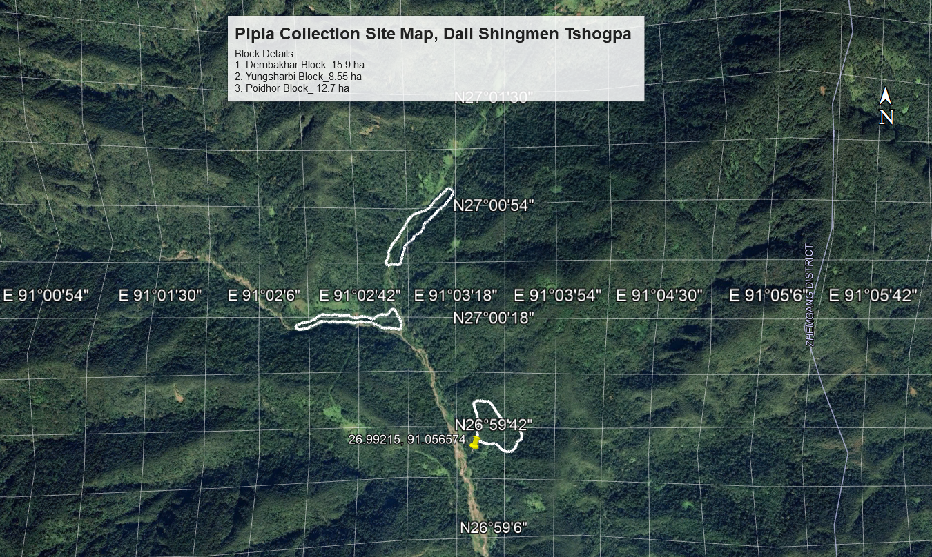
The Pipla collection site is identified at three locations viz. Dembakhar (39.27 acres), Yungsharbi (21.12 acres) and Poidhor (31.37 acres) and Rubia collection site is identified at four locations viz.
Figure 1. Pipla collection area map
Yaliwa Ree (17 acres), Pongseng (17.5 acres), Pong Nadhang (28 acres) and Bamdarlung (5 acres). The map of these collection sites is as shown in figure 2.
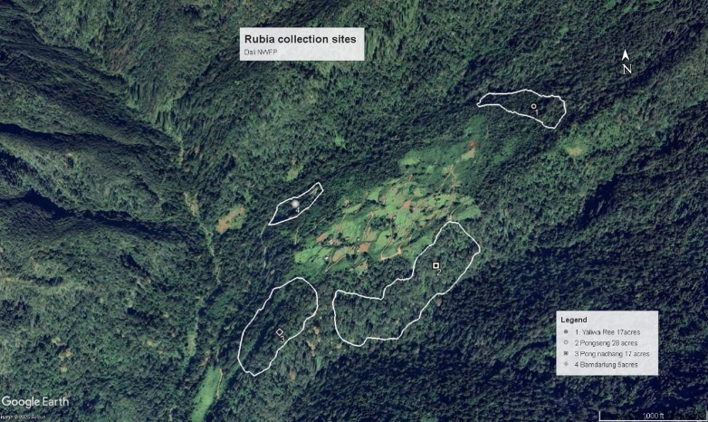

Figure 2. Rubia collection area map

6. Marketing and sales plan
The group plans to expand the sale of Non-Wood Forest Products (NWFPs) to major markets, including Thimphu, Phuentsholing, Gelephu, and other potential buyers. To enhance marketability and value, both Pipla and Rubia will undergo processing before being introduced to the market. Meanwhile, the sale of other NWFPs will be determined by customer demand, ensuring a flexible and responsive supply approach. The pricing, quantity, and overall value of sales will be aligned with prevailing market rates to maintain competitiveness and profitability. These details are systematically outlined in table 3 which provides an overview of estimated market trends, pricing structures, and sales projections to guide strategic decision-making.
Table 3. Marketing and sales plan
NWFPs | Potential market | Estimated quantity for sale per season (unit) | Estimated price per unit(Nu) | Total estimated income(Nu)
Piper pedicellatum | KNC, ITMS, Gelephu, Phuentsholing. | 83.4 kg | 150/kg | 12,510.00
Rubia cordifolia | ITMS, Bhutanese Dealers | 702.96 kg | 100/-kg | 70,296.00

7. Marketing arrangements
The marketing arrangements for the NWFP involves the following strategies to promote sustainable utilization of the resources
Activity | Brief description on how the activities shall carry out
Harvesting of products | - The Chairperson of NWFP group will obtain harvesting/collection permit from forest office in writing.  - The Chairperson will announce starting date for harvesting only after obtaining required permits from forest office.  - Only one member from each household will be collect NWFP for the first week and after that no limits is set for member involvement for collection.  - Harvesting prescriptions will be strictly followed by the collectors.  - Chairperson shall inform Range Office on completion of harvest.
Post-harvest practices | - The collectors are responsible for post-harvest processing of NWFPs.
Marketing of products | - The NWFPs will be handed over to the executive committee members for marketing after post-harvest processing.  - The executive committee members will sell the produce in presence of the group members to maintain transparency. In future the group plans to construct a common sale counter at the center to facilitate marketing of the NWFPs products.
Identification of buyers | - The Chairperson supported by other executive committee members will monitor and explore the demand from nearby institutes, agents, companies and other business groups.  - Support will also be sought from Department of Agriculture and Marketing Cooperatives (DAMC)
Price fixing | - The executive committee members will coordinate.
Income sharing | - 80% of the sales amount will be shared among the group members
Raising of community development fund | - A joint account in the name of the group will be opened. The account shall be managed by the executive committee members on behalf of the group.  - Annual membership fees, penalties and 15% of sale proceeds will be deposited in the community development fund.

8. Benefit to Members
To ensure equitable distribution and long-term sustainability, each household will be allowed one member to participate in the collection of Non-Wood Forest Products (NWFPs). This approach promotes fairness while maintaining a balanced harvesting process within the group. The collection schedule, including specific dates and timings, will be determined by the Chairman, following the management prescriptions and by-laws established by the group. These guidelines ensure that harvesting activities align with sustainable practices while preventing overexploitation of resources.
The revenue generated from NWFP sales will be allocated as follows:
- Community Development Fund (15%) – To strengthen financial sustainability, 15% of the total income from NWFP sales will be deposited into the group’s bank account. This revolving fund will support future investments, operational expenses, and unforeseen costs associated with resource management.
- Operational and Management Costs – Any expenses incurred in managing the NWFP collection process, including equipment, administrative costs, and sustainable harvesting initiatives, will be covered using the accumulated group fund.
- Member Profit-Sharing (80%) – After sales are finalized, 80% of the total revenue will be equally distributed among all participating members. This ensures that each household benefits directly from their contributions to the collection and marketing efforts.
- Transportation Costs (5%) – To facilitate smooth logistics, 5% of the total earnings will be allocated for transporting raw materials from collection sites to designated sales points. This provision helps reduce the burden of transport expenses on individual members while ensuring timely delivery of NWFPs to the market.

By implementing this structured benefit-sharing mechanism, the group aims to promote financial transparency, enhance collective responsibility, and foster a sustainable livelihood model for all its members.

8. Monitoring and Evaluation
To ensure that the Non-Wood Forest Products (NWFP) group operates in accordance with the prescribed management plan, an annual monitoring, mid-term review and final evaluation of the group will be conducted by the Beat Office, Bjoka, under the DFO Zhemgang as per the Forest Monitoring and Evaluation Framework, 2024 (FMEF).

Part B: Group Regulation and Norms (By-Law)

Village | Number of member house holds | Gewog
Dali | 28 HH | Bjoka

Responsibilities and Rights of the Members
Each member of the group is expected to fulfill the following duties and adhere to the guidelines:
- Implement the annual activities outlined in the management plan.
- Attend ad-hoc meetings and participate in group activities as directed by the executive members.
- Prevent and report on any illegal activities related to NWFP collection and trade.
- Harvest NWFPs strictly as per the prescribed management plan to ensure sustainability.
- Cooperate with the executive members in all group-related activities.
- Follow the management guidelines and abide by all rules and regulations.

Members of the NFWP management & marketing group
Membership arrangement | - Every household in Dali Chiwog is eligible to become a member of the group.  - Households with census records in the chiwog may apply to join the management group after consulting with existing members.
Procedure for becoming a member | - Former civil servants interested in joining after retirement must pay a membership fee of Nu. 5,000 plus all membership fees accumulated to date.  - If a fragmented household within the chiwog wishes to join, they must contribute the same membership fee as existing members.  - Members must contribute annually by collecting 5 kg of dried Rubia and 2 kg of Pipla to support the group's income and strengthen operational sustainability.  - Any interested individuals may apply for membership by submitting a formal application to the Chairperson.  - Membership approval or rejection will be determined through a unanimous decision during group meetings.
Procedure for Leaving the Group | - Members who wish to withdraw must submit a formal request to the Chairperson.  - No financial benefits accumulated by the group will be granted to members who leave voluntarily.

Executive committee
Selection Criteria for Executive Members | - Executive members will be elected by a majority vote from the group through a unanimous decision.  - The selected executive members will serve a tenure of five years, unless deemed incapable or unfit.  - New executive members will be appointed during a general meeting, with forestry officials present
Chairperson | Name of Chairperson: Mr. Jambay Tshering
Responsibilities of Chairperson/Coordinator
- Identify and explore market opportunities for NWFP sales.
- Plan, organize, and coordinate all activities related to NWFP collection and management.
- Collaborate with relevant stakeholders, including government agencies and buyers.
- Organize and facilitate meetings for the group.
- Mediate and resolve conflicts within the group.
- Submit an annual report to the forestry office.
Secretary | Name of Secretary: Mr. Sonam Phuntsho
Responsibilities of Secretary:
- Obtain collection permits from the nearest forest office.
- Act as the officiating chairperson in the chairperson’s absence and assist in planning and implementation.
- Maintain accurate records of group activities and meeting minutes.
- Ensure proper documentation and archiving of official proceedings.
Treasurer | Name of Treasurer: Mr. Tenzin
Responsibilities of Treasurer:
- Maintain financial records and track all cash transactions.
- Collect and deposit membership fees into the group’s bank account.
- Keep an attendance record of meetings and labor contributions.
- Present financial reports to the members annually during the general meeting.
- Oversee all financial arrangements for the group.

Source for generation of group fund
Membership Fees | - Each household is required to contribute Nu. 100 per year to the group’s bank account.
Community Fund & Compensation to the executive committee for marketing | - Loans will be provided to both members and outsiders, but only in the presence of a forestry official.  - Before disbursing any loan, the group account must have accumulated at least Nu. 200,000.  - Loan interest rates:  - 10% per annum for outsiders.  - 5% per annum for members.  - Maximum loan amount: Nu. 30,000 per individual.  - Any member undertaking an official tour on behalf of the group will be entitled to a daily subsistence allowance (DSA) of Nu. 500 per day.  - If the tour expenses are covered by another agency, DSA will not be provided.  - Members must deposit 5% of NWFP sales revenue into the group account.  - At the end of the management plan period, all accumulated funds will be equally distributed among members.
Membership fee and purpose | - Membership fee of Nu 100/- will be collected annually per member.

Community development fund and utilization of fund | - The membership fees along with fines and penalties and 5% from sales of the product shall be deposited as community development fund in the joint account.  - Any expenditures incurred in the name of the group will be met from community development fund.  - When the fund accumulates more than two hundred thousand, the fund will be utilized for community ritual, supporting the poor and disaster affected households.
Meetings | - All members must attend the annual planning meeting before NWFP harvesting begins in March each year.  - The committee members will hold a meeting in November to review and report on financial and physical progress.  - Members will attend training sessions on a rotational basis, with priority given to executive members.  - Members who attend training sessions must share the knowledge gained with the group during the general meeting.

Conflict resolution
Internal disputes | - Any internal disputes within the group will be resolved by the Chairperson.  - If the dispute is beyond the Chairperson’s authority, it will be escalated to the Gewog Administration for resolution.
Conflict involving external parties | - In the case of a conflict involving external parties, the matter will be forwarded to the Divisional Forest Office and Gewog Administration for further action.
Penalties | - Failure to attend meetings or group work: Fine of Nu. 215 per absence.  - Unauthorized NWFP collection during off-season: Fine of Nu. 1,000 per incident.  - Selling NWFPs without committee approval: Fine of Nu. 1,500, plus a compensation fee based on the market value of the product as per the management plan.  - Harvesting violations: Fine of Nu. 1,500, and the member will be banned from harvesting for the next season.  - Illegal NWFP trading by outsiders: Minimum fine of Nu. 3,000, plus compensation at double the market rate specified in the management plan.  - Penalties not explicitly mentioned here will be determined based on the Forest Rules and double the prescribed rates.  - Failure to collect the required quantity of Rubia (5 kg) and Pipla (2 kg) annually will result in a fine of Nu. 250 per shortfall, which will be deposited into the group account.

Powers of the Department

The Department shall:
• Take action against violators of the Act, Rules, or Management Plan as per the provision of FNCA2023 and FNCRR 2023and upon request by the NWFMG.
• Conduct inspections, monitoring, and reviews of NWFMG records and oversee its activities to ensure compliance.
• Enforce necessary actions, including certificate cancellation, if the NWFMG or any of its members violate the provisions of the Management Plan, FNCRR and FNCA.

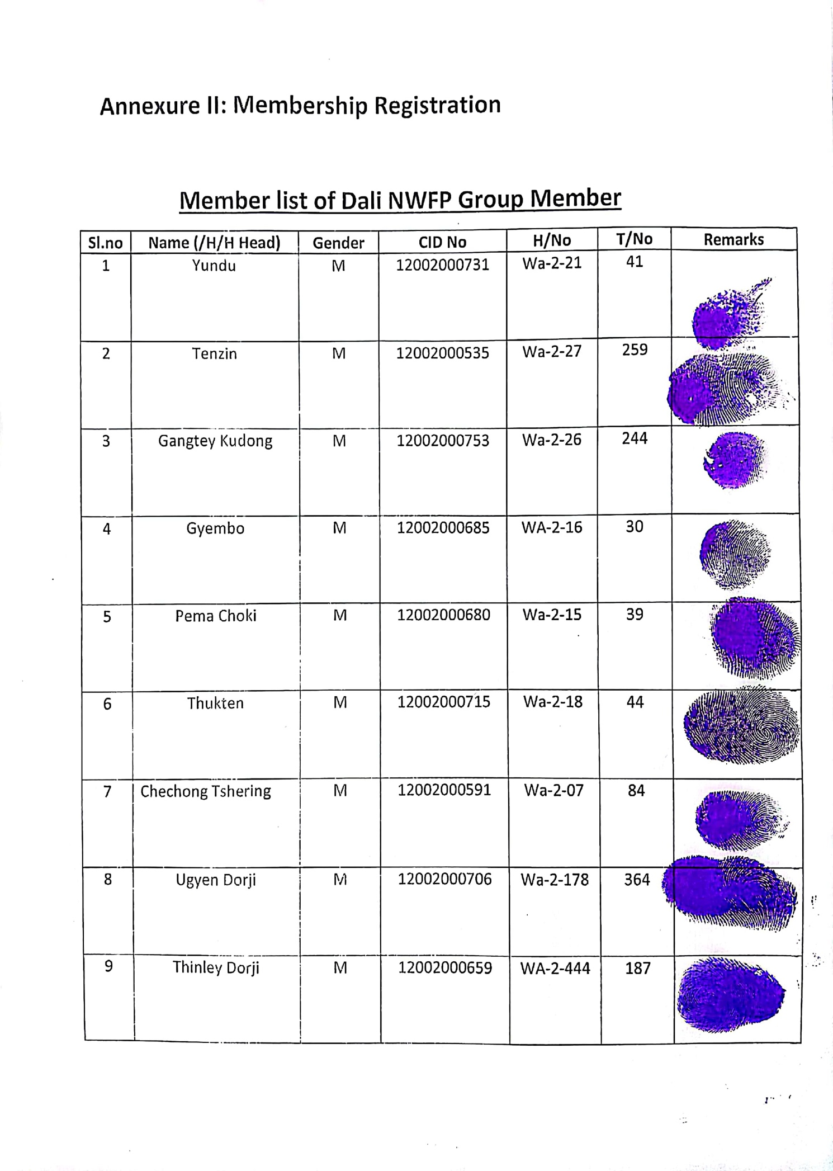
Annexure I: Membership list


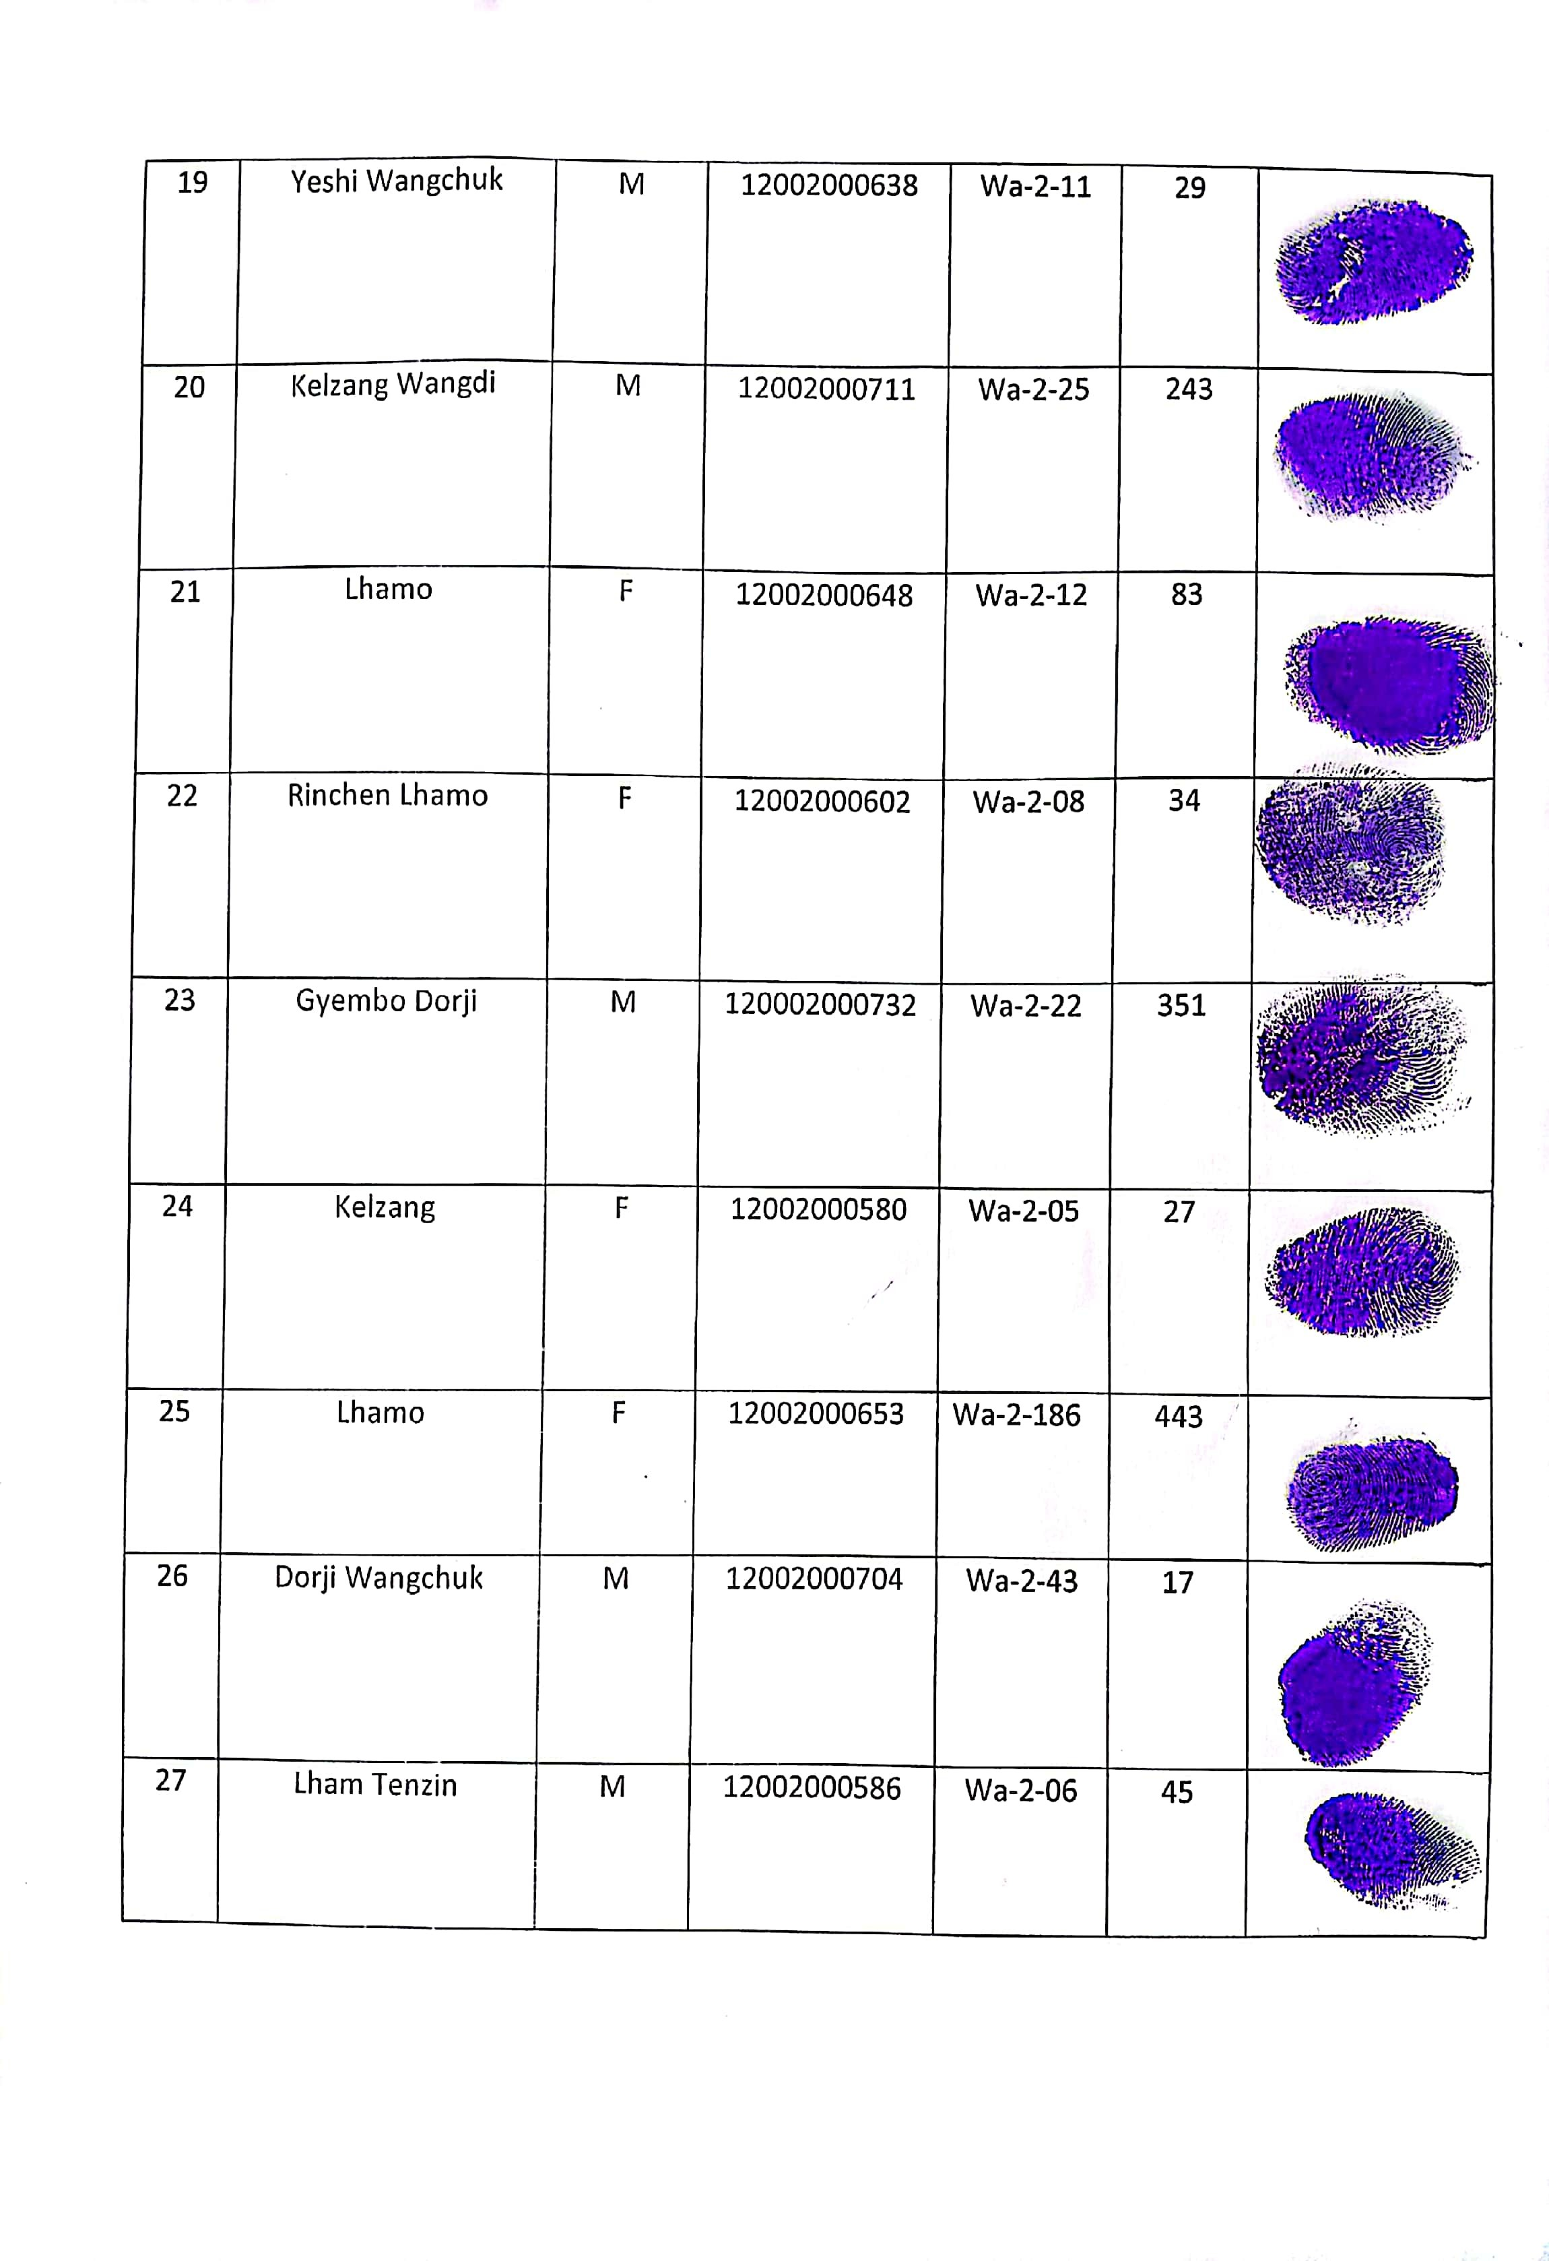

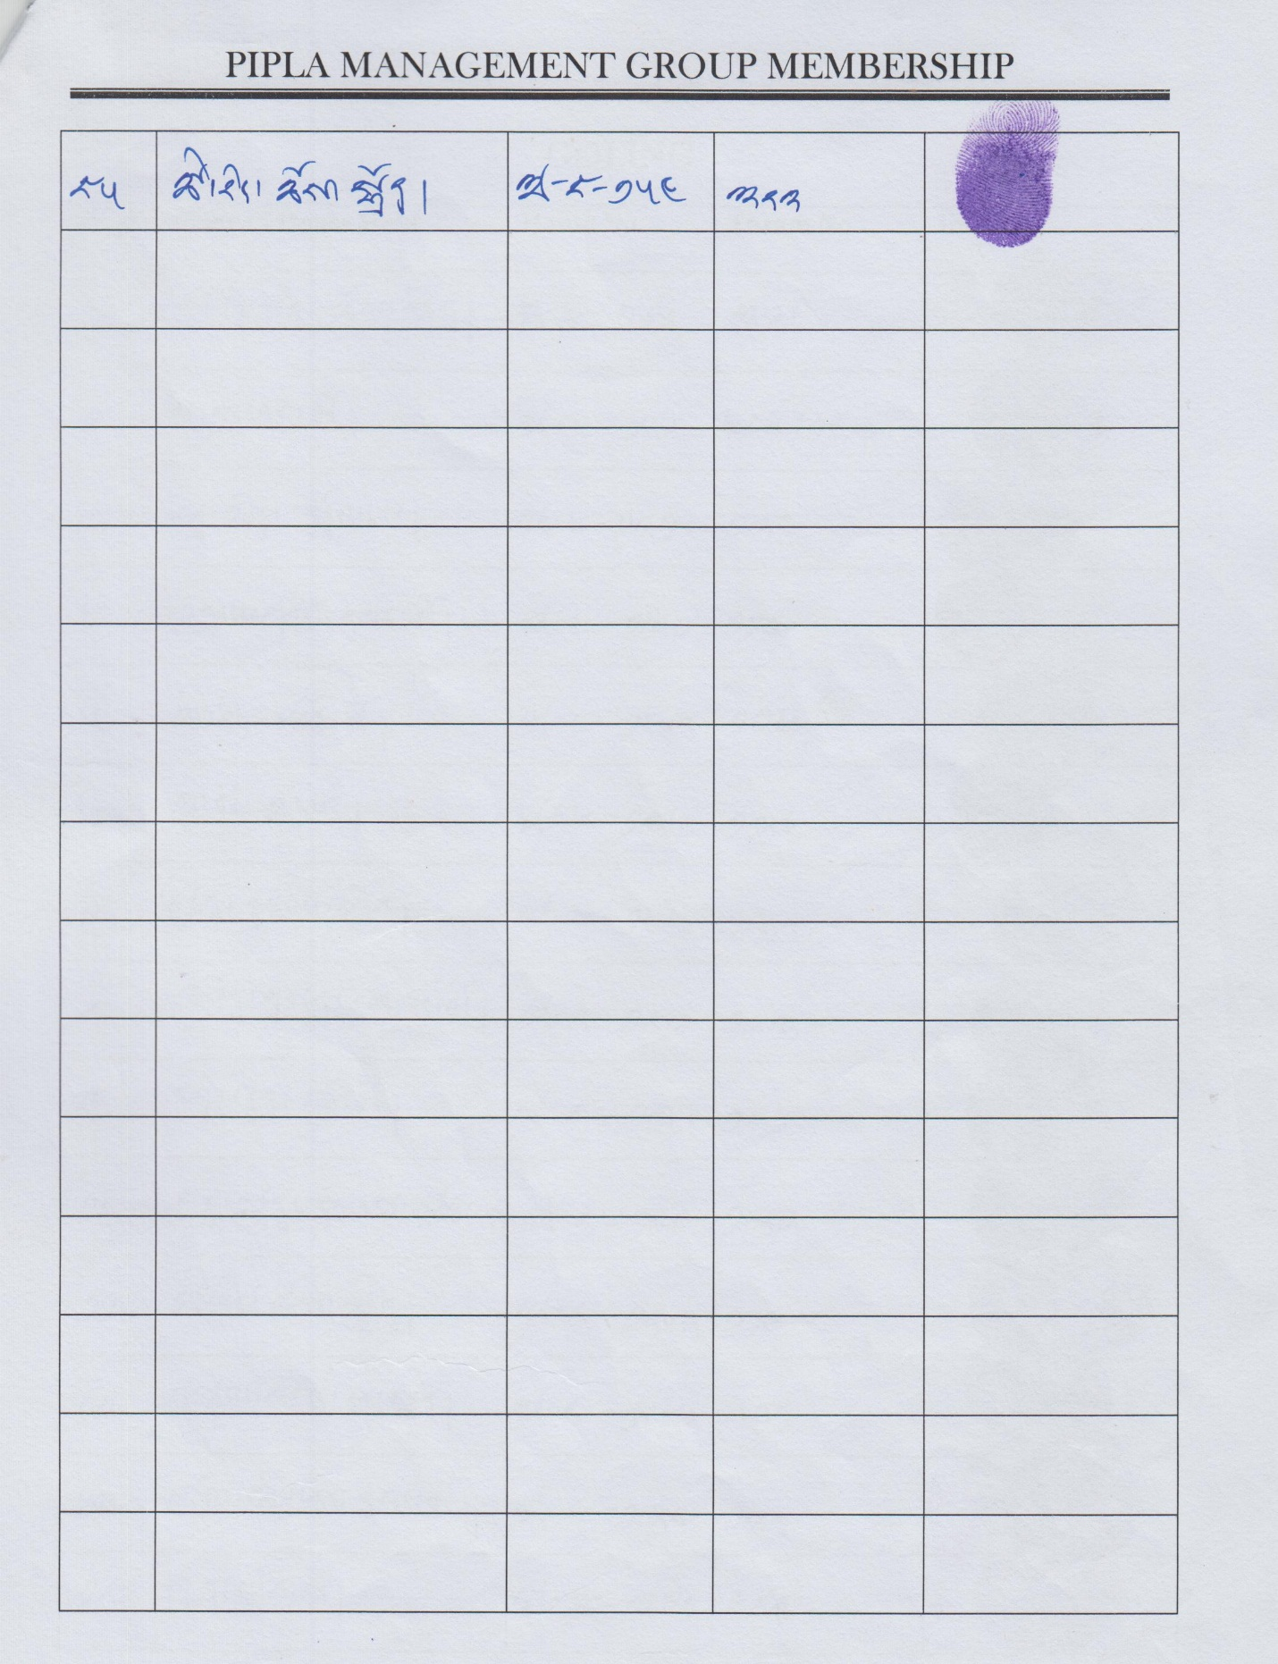

Annexure II: Resource Assessment of Pipla
The resource assessment of Pipla aims to estimate the quantity (in kilograms) of berries that can be sustainably harvested from the designated blocks. For the current revision cycle, it was not possible to carry out a fresh assessment due to the mismatch with the fruiting season of the species during the revision period. The estimates have been made using past five years data as depicted below;
Assessment of Pipla productivity based on harvesting records
Name of Dzongkhag: Zhemgang
Name of Gewog: Bjoka
Records available over period/years:
Village | Quantity of harvested dried berries (kg) over last 5 years |  |  |  |  | Average dried Pipla production (kg)
 | Year 1 | Year 2 | Year 3 | Year 4 | Year 5
Dali | 98 | 70 | 112 | 84 | 56 | 84

Block description form for Pipla
Date: 5/4/2025
Village: Dali Name of forest area: Dembakhar
Block name: Dembakhar Block area (ha): 15.9
Access | Walking distance from the nearest village to the block?
 | Less than 3 hours | Within a day | More than a day
 | Walking distance from the block to the nearest road?
 | Less than 3 hours | Within a day | More than a day

Slope | Very steep  >100% | Steep  70-100% | Moderate  45-70% | Gentle  <45%

Forest description | Dominant and associate species, canopy cover: Lithocarpus sp., Duabanga grandifloia, Terminalia spp., Schima spp.

Block | No | Density | Area(ha) | Productive area (%) | No. of transect -areas
 | 1 |  | 15.9 | 78 | 4

Current Management | Current management practices in entire block: Un-managed area.

Current threats | Threat | Description
 | Fire
 | Grazing
 | Illegal exploitation | By other communities
 | Over-exploitation
 | Other

Opportunities | Future opportunities for entire block: Productive areas if managed and harvested sustainably.

Date: 6/4/2025
Village: Dali Name of forest area: Yungsharbi
Block name: Yungsharbi Block area (ha): 8.55
Access | Walking distance from the nearest village to the block?
 | Less than 3 hours | Within a day | More than a day
 | Walking distance from the block to the nearest road?
 | Less than 3 hours | Within a day | More than a day

Slope | Very steep  >100% | Steep  70-100% | Moderate  45-70% | Gentle  <45%

Forest description | Dominant and associate species, canopy cover: Lithocarpus sp., Duabanga grandiflora, Terminalia spp., and Schima spp.

Block | No | Density | Area(ha) | Productive area (%) | No. of transect -areas
 | 1 |  | 8.5 | 85 | 2

Current Management | Current management practices in entire block: Un-managed area.

Current threats | Threat | Description
 | Fire
 | Grazing | Community freely graze their domestic animals within the block
 | Illegal exploitation
 | Over-exploitation
 | Other

Opportunities | Future opportunities for entire block: Productive areas if managed and harvested sustainably.

Date: 6/4/2025
Village: Dali Name of forest area: Poidhor
Block name: Poidhor Block area (ha): 12.7
Access | Walking distance from the nearest village to the block?
 | Less than 3 hours | Within a day | More than a day
 | Walking distance from the block to the nearest road?
 | Less than 3 hours | Within a day | More than a day

Slope | Very steep  >100% | Steep  70-100% | Moderate  45-70% | Gentle  <45%

Forest description | Dominant and associate species, canopy cover: Lithocarpus sp., Daubanga grandifolia, Terminalia spp., Schima spp.

Block | No | Density | Area(ha) | Productive area (%) | No. of transect -areas
 | 1 |  | 12.7 | 87 | 3

Current Management | Current management practices in entire block: Un-managed area.

Current threats | Threat | Description
 | Fire
 | Grazing | Community freely graze their domestic animals within the block
 | Illegal exploitation
 | Over-exploitation
 | Other

Opportunities | Future opportunities for entire block: Productive areas if managed and harvested sustainably.

Annexure III: Resource Assessment of Rubia cordifolia
The resource assessment for Rubia cordifolia focuses on estimating the sustainable harvestable quantity of stems (in kilograms) from the identified areas. The methodology relies primarily on historical harvest records maintained by the community group, as well as sales data from the preceding year. To estimate average availability, harvest records from two alternate years were analyzed.
Given the plant’s weedy nature and its role as a pioneer species commonly found along agricultural boundaries and disturbed sites, a full-scale scientific inventory was deemed impractical. Instead, sustainable harvest limits are set in accordance with established guidelines.
Prior to the assessment, designated community members conducted participatory mapping of potential Rubia production zones. Natural landmarks—such as rivers, streams, and rocky outcrops—were used to define the boundaries. Field assessments were conducted in groups, each comprising 10 members.
Participatory Resource Mapping (Block Descriptions)
Block 1: Yaliwa Ree
- Total Area: 17 acres
- Average Yield: 3.04 kg/acre
- Vegetation Type: Dominated by Phoebe sp. and Mallotus sp. in the canopy
- Aspect: North-East facing slope
- Elevation: 1,230 masl
- Slope: < 45% (gentle slope)
- Threats: Significant grazing pressure; no fire risk
- Accessibility: Within a 3-hour walk from the community
- Future Potential: High, with noticeable seedling regeneration
- Current Management: Alternate-year harvesting
- Coordinates: 27°03'9014"N, 91°07'4450"E
- Estimated Production:
  - Total Plots: 68 (40/10 × 17 acres)
  - Total Output: 68 plots × 3.04 kg/acre = 206.72 kg

Block 2: Pongseng
- Total Area: 17.5 acres
- Average Yield: 3.38 kg/acre
- Vegetation Type: Castanopsis sp., Albizia sp., and Schefflera sp.
- Aspect: South-East facing slope
- Elevation: 1,220 masl
- Slope: 45–70% (moderate)
- Threats: Grazing, minor fire risk
- Accessibility: Within a 3-hour walk from the community
- Future Potential: Promising, with visible sprouting
- Current Management: Alternate-year harvesting
- Coordinates: 27°02'9839"N, 91°06'8881"E
- Estimated Production:
  - Total Plots: 70 (40/10 × 17.5 acres)
  - Total Output: 70 plots × 3.38 kg/acre = 236.6 kg

Block 3: Pong Nadhang
- Total Area: 28 acres
- Average Yield: 1.97 kg/acre
- Vegetation Type: Castanopsis sp. and Schefflera sp.
- Aspect: South-East facing slope
- Elevation: 1,218 masl
- Slope: < 45% (gentle slope)
- Threats: Grazing by cattle; minor fire risk
- Accessibility: Within a 3-hour walk from the community
- Future Potential: High, with sprouting shoots present
- Current Management: Alternate-year harvesting
- Coordinates: 27°01'495036"N, 91°03'48144"E
- Estimated Production:
  - Total Plots: 112 (40/10 × 28 acres)
  - Total Output: 112 plots × 1.97 kg/acre = 220.64 kg

Block 4: Bamdarlung
- Total Area: 5 acres
- Average Yield: 1.97 kg/acre
- Vegetation Type: Albizia sp. and Lithocarpus sp.
- Aspect: South-West facing slope
- Elevation: 1,186 masl
- Slope: < 45% (gentle slope)
- Threats: Grazing pressure; minimal fire risk
- Accessibility: Within a 3-hour walk from the community
- Future Potential: High, with emerging sprouts
- Current Management: Alternate-year harvesting
- Coordinates: 27°02'6552"N, 91°03'5784"E
- Estimated Production:
  - Total Plots: 20 (40/10 × 5 acres)
  - Total Output: 5 acres × 1.97 kg/acre = 39 kg
Appendix 2: Production area description for Rubia cordifolia
Sl. No. | Block No. | Block Area (Acres) | Quantity (Kg) | Remarks
1 | Yaliwa Ree | 17 | 206.72 | Fresh/Dry weight conversion required
2 | Pongseng | 17.5 | 236.6 | Fresh/Dry weight conversion required
3 | Pong Nadhang | 28 | 220.64 | Fresh/Dry weight conversion required
4 | Bamdarlung | 5 | 39 | Fresh/Dry weight conversion required
This assessment provides an overview of Rubia cordifolia production in different blocks, aiding in sustainable harvesting and resource management planning.
Sl. No. | Block No. | Block Area (Acres) | Quantity (Kg) | Remarks
1 | Yaliwa Ree | 17 | 206.72
2 | Pongseng | 17.5 | 236.6
3 | Pong Nadhang | 28 | 220.64
4 | Bamdarlung | 5 | 39

